LINEAR DISCRIMINANT ANALYSIS (LDA):
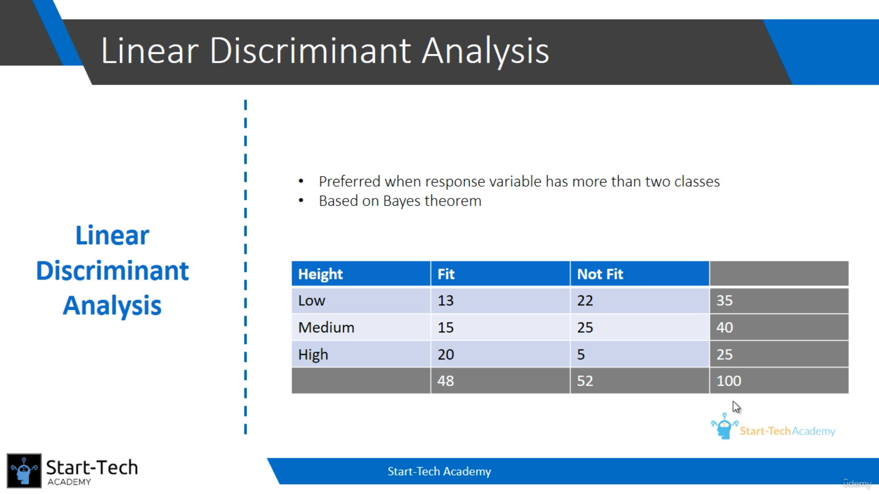
Probability of ‘Fit’ given ‘Medium’ is 15/40. This is called conditional probability.
But in real dataset, we can’t able variable of categorical values only. We are having continuous variables. So, we use Bayes theorem.
